# Written Part

# Q1

* The dominant wavelength of color D can be found using the following methods: Start from the white color (E point) and grows a line towards D and make the line intersect with the diagram at point D’, the y coordinate of that point D’ should be dominant wavelength of color D
* No. not all colors have a dominant wavelength. Suppose there is a point P located at the bottom part of the diagram, where the corresponding point P’ found using method mentioned above is appeared on the straight line. For this situation, P don’t have a dominant wavelength.
* Start from color C and grow a line towards white color (E point) and make the line intersect with the diagram at C’, the y coordinate of that point C’ should be dominant wavelength of the color complimentary to color C
* Connect points GR and grow a line from B to E intersecting on GR at Q. Connect points GB and grow a line from R to E intersecting on GR at Q’. Connect Q and Q’ to get points with value of G equals to 0.5. Since point E is with same value of RGB, point B is with the save value of R and G, then the points on connection BE will have the same value of R and G. Point R is with the same value of B and G, then the points on the connection BR will have the same value of B and G. Hence, QQ’ is with the same amount of value G of 0.5.

# Q2

|  |  |  |  |  |  |  |  |
| --- | --- | --- | --- | --- | --- | --- | --- |
| Level 0 | Level 1 | Level 2 | Level 3 | Level 4 | Level 5 | Level 6 | Level 7 |
| 0.25 | 0.50 | 0.75 | 1.00 | 1.25 | 1.50 | 1.75 | 2.00 |
| Level 8 | Level 9 | Level 10 | Level 11 | Level 12 | Level 13 | Level 14 | Level 15 |
| 2.25 | 2.50 | 2.75 | 3.00 | 3.25 | 3.50 | 3.75 | 4.00 |
| Level 16 | Level 17 | Level 18 | Level 19 | Level 20 | Level 21 | Level 22 | Level 23 |
| 4.25 | 4.50 | 4.75 | 5.00 | 5.25 | 5.50 | 5.75 | 6.00 |
| Level 24 | Level 25 | Level 26 | Level 27 | Level 28 | Level 29 | Level 30 | Level 31 |
| 6.25 | 6.50 | 6.75 | 7.00 | 7.25 | 7.50 | 7.75 | 8.00 |

* The quantized interval should look above. Hence the signal should be:

|  |  |  |  |  |  |  |  |
| --- | --- | --- | --- | --- | --- | --- | --- |
| 5.80 | 6.20 | 6.20 | 7.20 | 7.30 | 7.30 | 6.50 | 6.80 |
| Level 22 | Level 24 | Level 24 | Level 28 | Level 28 | Level 28 | Level 25 | Level 26 |
| 6.80 | 6.80 | 5.50 | 5.00 | 5.20 | 5.20 | 5.80 | 6.20 |
| Level 26 | Level 26 | Level 21 | Level 21 | Level 20 | Level 20 | Level 22 | Level 24 |
| 6.20 | 6.20 | 5.90 | 6.30 | 5.20 | 4.20 | 2.80 | 2.80 |
| Level 24 | Level 24 | Level 23 | Level 24 | Level 20 | Level 16 | Level 10 | Level 10 |
| 2.30 | 2.90 | 1.80 | 2.50 | 2.50 | 3.30 | 4.10 | 4.90 |
| Level 8 | Level 11 | Level 6 | Level 9 | Level 9 | Level 12 | Level 15 | Level 19 |

* The bits need to transmit the signal should be $32×\log_{2}{32}=160 bits$
* The successive differences are listed as follows

|  |  |  |  |  |  |  |  |
| --- | --- | --- | --- | --- | --- | --- | --- |
|  | 2 | 0 | 4 | 0 | 0 | -3 | 1 |
| 0 | 0 | -5 | 0 | -1 | 0 | 2 | 2 |
| 0 | 0 | -1 | 1 | -4 | -4 | -6 | 0 |
| -2 | 3 | -5 | 3 | 0 | 3 | 3 | 4 |

, where the maximum value is 4, the minimum value is -6, and the range should be [-6, 4]. Suppose this is the new range, bits needed for transmission should be $31×\log_{2}{16}=124 bits$.

* The compression ratio should be $\frac{124}{160}×100\%=77.5\%$
* The Huffman code for the differences should be as follows

|  |  |  |  |
| --- | --- | --- | --- |
| Node | Frequency | Huffman Code | Length |
| -1.4 | 1 | 11111 | 5 |
| -1.3 | 1 | 11110 | 5 |
| -1 | 1 | 11101 | 5 |
| -0.8 | 1 | 11100 | 5 |
| -0.3 | 1 | 11011 | 5 |
| 0.1 | 1 | 11010 | 5 |
| 0.2 | 1 | 11001 | 5 |
| 0.3 | 1 | 11000 | 5 |
| 0.7 | 1 | 01111 | 5 |
| 1 | 1 | 01110 | 5 |
| -1.1 | 2 | 0110 | 8 |
| -0.5 | 2 | 0101 | 8 |
| 0.6 | 2 | 0100 | 8 |
| 0.4 | 3 | 101 | 9 |
| 0.8 | 3 | 100 | 9 |
| 0 | 9 | 00 | 18 |

, where the total bits that needed is 110 bits

The compression ratio should be $\frac{110}{160}×100\%=68.75\%$

# Q3

* There are 8 types three symbol units with following probabilities

|  |  |
| --- | --- |
| AAA | 0.512 |
| AAB | 0.128 |
| ABA | 0.128 |
| ABB | 0.032 |
| BAA | 0.128 |
| BAB | 0.032 |
| BBA | 0.032 |
| BBB | 0.008 |

* The arrangement of these symbol units should be

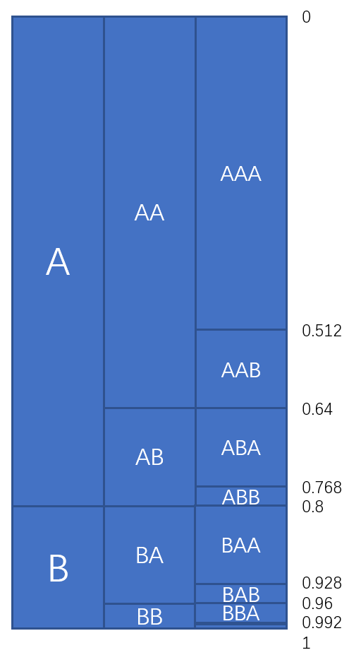

Hence the code for each should be

|  |  |  |
| --- | --- | --- |
| Input | Arithmetic Form | Code |
| AAA | 1/2 | .010 |
| AAB | 5/8 | .1010 |
| ABA | 11/16 | .10110 |
| ABB | 23/32 | .10111 |
| BAA | 7/8 | .1110 |
| BAB | 30/32 | .11110 |
| BBA | 31/32 | .111110 |
| BBB | 127/128 | .1111111 |

* The average code word length is 3.8, which is not optimal
* The bits required to code the message should be $Code\left(ABA\right)+Code\left(BBA\right)+Code\left(ABB\right)+Code\left(AAA\right)+Code\left(BBB\right)=27 bits$
* Using 1 for A and 0 for B.

# Q4

* The entropy function should be $E=∑P\left(i\right)\log_{2}\left(P\left(i\right)\right)=-P\left(X\right)\log_{2}\left(P\left(X\right)\right)-P\left(Y\right)\log_{2}\left(P\left(Y\right)\right)=-x^{2}\log_{2}{x^{2}-\left(1-x^{2}\right)\log_{2}\left(1-x^{2}\right)}$

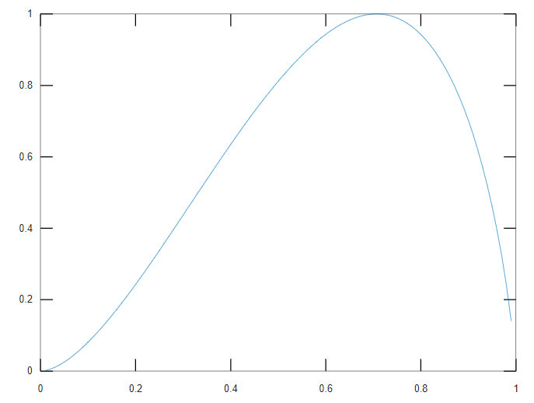

* From the plot, when x is 0 or 1, the Entropy become the minimum.

$f\left(x\right)=-\left[x^{2}\log_{2}{x^{2} +\left(1-x^{2}\right)\log_{2}\left(1-x^{2}\right)}\right]$

$$-f^{'}\left(x\right)={\left[x^{2}\log_{2}{x^{2}}\right]}^{'}+{\left[\left(1-x^{2}\right)\log_{2}\left(1-x^{2}\right)\right]}^{'}$$

$$=2xlog_{2}x^{2}+x^{2}\frac{2x}{x^{2}\ln{2}}+\left(-2x\right)\log_{2}\left(1-x^{2}\right)+\left(1-x^{2}\right)\frac{-2x}{\left(1-x^{2}\right)\ln{2}}$$

$$=2xlog_{2}x^{2}+\frac{2x}{\ln{2}}-2xlog_{2}\left(1-x^{2}\right)-\frac{2x}{\ln{2}}$$

$$=2x\left(\log_{2}{x^{2}-\log_{2}\left(1-x^{2}\right)}\right)$$

, where if and only if $x=0$ or $x^{2}=1-x^{2}$ will make the equation equals to zero, leading to $x_{1}=0,x_{2}=\frac{\sqrt{2}}{2}$. Since $0$ is the starting point, for $x∈\left(0,\frac{\sqrt{2}}{2}\right)$, $f^{'}\left(x\right)>0$, and for $x∈\left(\frac{\sqrt{2}}{2},1\right)$, $f^{'}\left(x\right)<0$. The minimum value should be at $x=0$ and $x=1$.

* Based on the derivative calculated above, we just need to calculate the value of 1 and 0 and compare since for $x∈\left(0,\frac{\sqrt{2}}{2}\right)$, $f^{'}\left(x\right)>0$, and for $x∈\left(\frac{\sqrt{2}}{2},1\right)$, $f^{'}\left(x\right)<0$. Hence, the maximum value should be equal to $f\left(\frac{\sqrt{2}}{2}\right)=1$